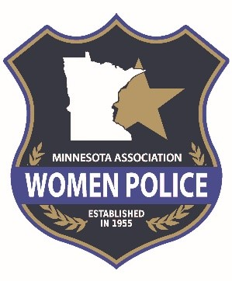
Minnesota Association of Women Police

303 South State Street
Waseca, MN 56093
mawpcommunications@gmail.com

Sponsorship Form for Annual Conference
Date of Event: ________________

The Minnesota Association of Women Police (MAWP) invites you to become a sponsor for our Annual Conference. This is a great opportunity to network and share information about your product or service with law enforcement personnel, educators, administrative leaders, and the MAWP membership. You or your organization may become involved by becoming a sponsor, and/or placing an advertisement in the conference program, or donating to our silent auction.
Sponsorship Packages Include:

GOLD ($500): Benefits include special recognition, large logo advertisement in the conference program, logo displayed during the conference. Link to sponsors website on the MAWP website with logo.

SILVER ($300): Benefits include a small logo advertisement in the conference program and link to sponsors website

BRONZE ($100): Benefits include recognition in conference program.

TO REGISTER your organization as a sponsor for the annual Conference:
Mail appropriate payment to:
MAWP Conference Sponsorship
303 South State Street
Waseca, MN 56093

Or contact mawpcommunications@gmail.com

